DESIGN AND ANALYSIS OF ALGORITHM

SESSION-2

LAB EXPERIMENTS

NAME: S.PRITHISH

REG NO:192421134

1.Write a program that takes an input list of n numbers and creates a new list containing only the unique elements from the original list. What is the space complexity of the algorithm?
SOL:n = int(input("Enter size of list: "))
arr = []

for i in range(n):
arr.append(int(input("Enter element: ")))

unique = []

for i in arr:
if i not in unique:
unique.append(i)

print("Unique Elements:", unique)
OUTPUT:
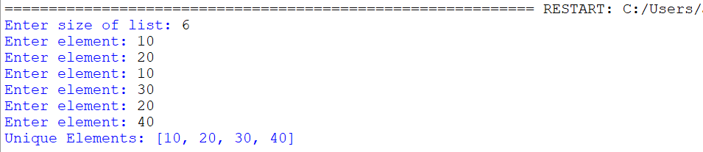

2.Sort an array of integers using the bubble sort technique. Analyze its time complexity using Big-O notation. Write the code
SOL:n = int(input("Enter size of array: "))
arr = []

for i in range(n):
arr.append(int(input("Enter element: ")))

for i in range(n - 1):
for j in range(n - i - 1):
if arr[j] > arr[j + 1]:
arr[j], arr[j + 1] = arr[j + 1], arr[j]

print("Sorted Array:", arr)
OUTPUT:
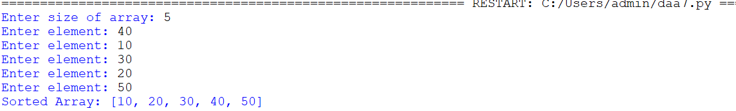

3.Checks if a given number x exists in a sorted array arr using binary search. Analyze its time complexity using Big-O notation.
SOL:n = int(input("Enter size of array: "))
arr = []

for i in range(n):
arr.append(int(input("Enter element: ")))

x = int(input("Enter number to search: "))

low = 0
high = n - 1
found = False

while low <= high:
mid = (low + high) // 2

if arr[mid] == x:
found = True
break
elif arr[mid] < x:
low = mid + 1
else:
high = mid - 1

if found:
print("Element Found")
else:
print("Element Not Found")
OUTPUT:
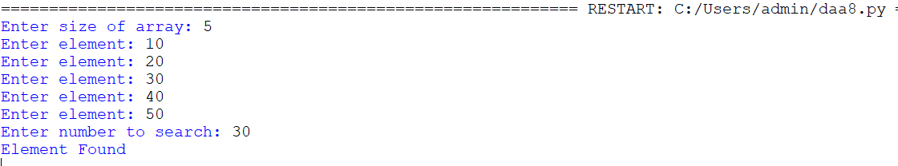

4. Given an array of integers nums, sort the array in ascending order and return it. You must solve the problem without using any built-in functions in O(nlog(n)) time complexity and with the smallest space complexity possible.
SOL:n = int(input("Enter size of array: "))
nums = []

for i in range(n):
nums.append(int(input("Enter element: ")))

def heapify(arr, n, i):
largest = i
left = 2 * i + 1
right = 2 * i + 2

if left < n and arr[left] > arr[largest]:
largest = left

if right < n and arr[right] > arr[largest]:
largest = right

if largest != i:
arr[i], arr[largest] = arr[largest], arr[i]
heapify(arr, n, largest)

for i in range(n // 2 - 1, -1, -1):
heapify(nums, n, i)

for i in range(n - 1, 0, -1):
nums[0], nums[i] = nums[i], nums[0]
heapify(nums, i, 0)

print("Sorted Array:", nums)
OUTPUT:
